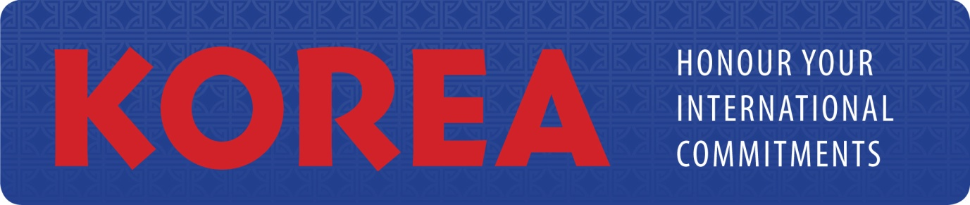

PRESS RELEASE

11 November 2010

INTERNATIONAL TRADE UNION CONFEDERATION (ITUC)

Global Unions decry continued labour rights violations in Korea

Brussels, 10 November 2010 (ITUC OnLine) :

On the occasion of the G20 meeting in Seoul, the global union movement is calling for the Korean government to honour its international commitments and respect workers’ rights.

Korea is one of the very worst countries in the industrialized world for the repression of its workers. The laws in Korea are used by the government and employers to routinely:
- Jail trade unionists for exercising their rights,
- Stop subcontracted workers from joining a union or bargaining collectively, and
- Prevent many public sector workers from joining a union or bargaining collectively.

The number of arrests, the severity of prison sentences and incidents of physical violence against workers are all increasing.

When Korea joined the OECD in 1996, the government made a commitment to bring its labour laws in line with internationally accepted standards. After initial progress on several issues, they failed to keep their promises when the OECD, over the objections of the Trade Union Advisory Committee (TUAC), lifted the monitoring.

At the time of the G20 meetings in Seoul, Korea has still failed to ratify the core conventions of the International Labour Organization (ILO) on freedom of association and the right to collective bargaining. The government has repeatedly refused ILO offers for technical assistance to reform its legislation to bring it in line with international standards.

Korean legislation is applied in a manner that repeatedly and systematically violates workers’ rights. The Korean government routinely uses criminal sanctions under Article 314 of the criminal code to arrest and imprison trade unionists for exercising their legitimate right to conduct trade union activities. The Korean law denies de facto workers in precarious or irregular employment the right to join a trade union and bargain collectively. Employers engage workers on precarious employment contracts, specifically to prevent them from forming and joining trade unions. Most workers in the pubic sector are subjected to anti-union discrimination and disciplinary measures and their collective agreements are unilaterally cancelled by the government. Whole categories of government workers are prevented from organizing through an overly broad definition of “essential services”.

In the lead-up to the G20 meetings, Korean President Lee Myung-bak has received hundreds of letters from trade unions all over the world, calling on him to honour Korea’s international commitments and respect workers’ rights. Speaking on behalf of global unions, Ambet Yuson, General Secretary of the Building and Woodworkers International (BWI) said, ‘If Korea wants to take its place alongside leading nations on a global platform like the G20, the government must fully meet its obligation to ensure the observance of fundamental labour rights in Korea. You can’t expect to be considered a world leader if you don’t respect workers’ rights.’

Global unions are calling on the Korean government to honour its international commitments and :
- amend section 314 of the Penal Code to bring it into conformity with freedom of association principles,
- release all trade unionists imprisoned for trade union activities,
- remove all legislative barriers to precarious workers exercising their rights to freedom of association and collective bargaining and prevent the abuse of subcontracting as a means of depriving them of their fundamental rights,
- fully guarantee the fundamental labour rights of public sector workers, including the right to join trade unions and to bargain collectively, and the right to freedom of expression,
- recognize and register the KGEU and the KPU (Korean Professors Union),
- remove legal barriers to public sector workers exercising their fundamental rights, such as the overly broad definition of “essential services”, and
- end threats to decertify the Korean Transport Workers Union (KTWU) and the Korean Construction Workers Union (KCWU) unless the unions expel members who are working in disguised employment relationships.

-Ends-

For more information, refer to a briefing note at: http://www.imfmetal.org/files/10101116193979/Briefing_Note_ENG.pdf

For comment please contact:
Ambet Yuson on +41 79 540 13 38
Jenny Holdcroft on +41 79 616 01 03

